- Consider lines with a slope of -1 that cross through nodes. Print all diagonal elements in a binary tree that belong to the same line, given a binary tree.
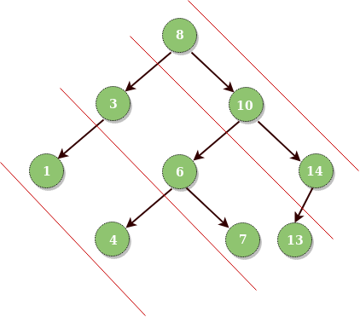
Output :
Diagonal Traversal of binary tree:
8 10 14
3 6 7 13
1 4
Solution:
// Tree node
class Node
{
int data;
Node left;
Node right;

// Constructor
Node(int data)
{
this.data = data;
left = null;
right = null;
}
}

class TNode
{
Node node;
int level;
public TNode(Node n, int l)
{
this.node = n;
this.level = l;
}
}

public void diagonalPrint(Node root)
{
if (root == null)
{
return;
}
TreeMap<Integer,List<Integer>> map = new TreeMap<>();

Queue<TNode> q = new LinkedList<>();

q.add(new TNode(root, 0));

while (!q.isEmpty())
{
TNode curr = q.poll();
map.putIfAbsent(curr.level, new ArrayList<>());
map.get(curr.level).add(curr.node.data);

if (curr.node.left != null)
{
q.add(new TNode(curr.node.left,
curr.level + 1));
}
if (curr.node.right != null)
{
q.add(new TNode(curr.node.right,
curr.level));
}
}

for(Map.Entry<Integer, List<Integer>>
entry : map.entrySet())
{
int k = entry.getKey();

List<Integer> l = map.get(k);
int size = l.size();

for(int i = 0; i < l.size(); i++)
{
System.out.print(l.get(i));
System.out.print(" ");
}
System.out.println("");
}
return;
}//function closed

2. Given the root of a binary tree, return the maximum path sum of any non-empty path.

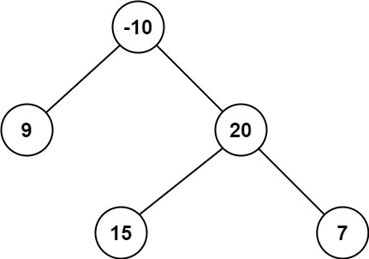

Input: root = [-10,9,20,null,null,15,7]
Output: 42
Explanation: The optimal path is 15 -> 20 -> 7 with a path sum of 15 + 20 + 7 = 42.

Solution:

int maxi = Integer.MIN_VALUE;

public int maxPathSum(TreeNode root) {
helper(root);
return maxi;
}

public int helper(TreeNode root) {
if(root == null)
return Integer.MIN_VALUE;
int left = Math.max(0, helper(root.left));
int right = Math.max(0, helper(root.right));
maxi = Math.max(maxi, root.val + left + right);
return root.val + Math.max(left, right);
}//function closed

- Given two integer arrays preorder and inorder where preorder is the preorder traversal of a binary tree and inorder is the inorder traversal of the same tree, construct and return the binary tree.
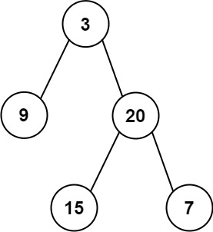

Input: preorder = [3,9,20,15,7], inorder = [9,3,15,20,7]
Output: [3,9,20,null,null,15,7]

Solution:

public static Node root;

// Store indexes of all items so that we
// we can quickly find later
static HashMap<Character,Integer> mp = new HashMap<>();
static int preIndex = 0;

/* Recursive function to construct binary of size
len from Inorder traversal in[] and Preorder traversal
pre[]. Initial values of inStrt and inEnd should be
0 and len -1.
*/
public static Node buildTree(char[] in, char[] pre, int inStrt, int inEnd)
{

if(inStrt > inEnd)
{
return null;
}

/* Pick current node from Preorder traversal using preIndex
and increment preIndex */
char curr = pre[preIndex++];
Node tNode;
tNode = new Node(curr);

/* If this node has no children then return */
if (inStrt == inEnd)
{
return tNode;
}

/* Else find the index of this node in Inorder traversal */
int inIndex = mp.get(curr);

/* Using index in Inorder traversal, construct left and
right subtress */
tNode.left = buildTree(in, pre, inStrt, inIndex - 1);
tNode.right = buildTree(in, pre, inIndex + 1, inEnd);
return tNode;
}

// This function mainly creates an unordered_map, then
// calls buildTree()
public static Node buldTreeWrap(char[] in, char[] pre, int len)
{
for(int i = 0; i < len; i++)
{
mp.put(in[i], i);
}
return buildTree(in, pre, 0, len - 1);

}//function closed

- Given two integer arrays inorder and postorder where inorder is the inorder traversal of a binary tree and postorder is the postorder traversal of the same tree, construct and return the binary tree.



Input: inorder = [9,3,15,20,7], postorder = [9,15,7,20,3]
Output: [3,9,20,null,null,15,7]

/* A binary tree node has data, pointer to left
child and a pointer to right child */
static class Node {
int data;
Node left, right;
};

// Utility function to create a new node
/* Helper function that allocates a new node */
static Node newNode(int data)
{
Node node = new Node();
node.data = data;
node.left = node.right = null;
return (node);
}

/* Recursive function to construct binary of size n
from Inorder traversal in[] and Postorder traversal
post[]. Initial values of inStrt and inEnd should
be 0 and n -1.
*/
static Node buildUtil(int in[], int post[], int inStrt,
int inEnd)
{

// Base case
if (inStrt > inEnd)
return null;

/* Pick current node from Postorder traversal
using postIndex and decrement postIndex */
int curr = post[index--];
Node node = newNode(curr);

/* If this node has no children then return */
if (inStrt == inEnd)
return node;

/* Else find the index of this node in Inorder
traversal */
int iIndex = mp.get(curr);

/* Using index in Inorder traversal, con
left and right subtrees */
node.right = buildUtil(in, post, iIndex + 1, inEnd);
node.left = buildUtil(in, post, inStrt, iIndex - 1);

return node;
}
static HashMap<Integer, Integer> mp = new HashMap<>();
static int index;

// This function mainly creates an unordered_map, then
// calls buildTreeUtil()
static Node buildTree(int in[], int post[], int len)
{

// Store indexes of all items so that we
// we can quickly find later
for (int i = 0; i < len; i++)
mp.put(in[i], i);

index = len - 1; // Index in postorder
return buildUtil(in, post, 0, len - 1);

}//function closed

- Given a binary tree, find the lowest common ancestor (LCA) of two given nodes in the tree.
According to the definition of LCA on Wikipedia: “The lowest common ancestor is defined between two nodes p and q as the lowest node in T that has both p and q as descendants (where we allow a node to be a descendant of itself).”
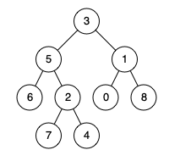

Input: root = [3,5,1,6,2,0,8,null,null,7,4], p = 5, q = 1
Output: 3
Explanation: The LCA of nodes 5 and 1 is 3.

Solution:

Node findLCA(Node node, int n1, int n2)
{
// Base case
if (node == null)
return null;

// If either n1 or n2 matches with root's key,
// report the presence by returning root (Note that
// if a key is ancestor of other, then the ancestor
// key becomes LCA
if (node.data == n1 || node.data == n2)
return node;

// Look for keys in left and right subtrees
Node left_lca = findLCA(node.left, n1, n2);
Node right_lca = findLCA(node.right, n1, n2);

// If both of the above calls return Non-NULL, then
// one key is present in once subtree and other is
// present in other, So this node is the LCA
if (left_lca != null && right_lca != null)
return node;

// Otherwise check if left subtree or right subtree
// is LCA
return (left_lca != null) ? left_lca : right_lca;
}
TC: O(n)
SC: O(h) where n is the number of nodes in tree and h is the height of tree.

